NATIONAL TEXTILE UNIVERSITY

Department of Computer Science


Project SRS

Gym Management System

Course Codeaaa COC-2072 (Software Engineering Fundamentals)
Lecturer’s Name DR.Inam Illahiaa aaaaaaaaaaaaaaaaa
Section aa a a a BSSE-A aaaaaaaaaaaaaaaaa

Student Name: _Abu-Bakar __ a_ Reg#_21-NTU-CS-1289______
Student Name: _Abubakar Nadeem Reg#_21-NTU-CS-1291_____ _
Student Name: _Huzaifa Ahmad _a Reg#_21-NTU-CS-1318______

Software Requirement Specification
Table of Contents

- Introduction
  - Purpose
  - Document Conventions
  - Intended Audience and Reading Suggestions
  - Product Scope

- Overall Description
  - Product Perspective
  - Product Functions
  - User Classes and Characteristics
  - Operating Environment
  - Design and Implementation Constraints
  - User Documentation
  - Assumptions and Dependencies

- External Interface Requirements
  - User Interfaces
  - Hardware Interfaces
  - Software Interfaces

- System Features
  - System feature 1(so on)

- Other Nonfunctional Requirements
  - Performance Requirements
  - Safety Requirements
  - Security Requirements
  - Software Quality Attributes
  - Business Rules
- Diagrams
  - Use Case Diagram

1.Introduction

- Purpose

Gym Management System provides the benefits of streamlined operations, enhanced administration & control. Gym Management System Service is powerful, flexible and easy to use and is designed and developed to deliver real conceivable benefits to Gym Owners.

Document Conventions

- Visual Studio(C# programming language)
- Microsoft SQL(For Databases)
- RAM - Random Access Memory.

- Document Conventions

    - Developers: in order to be sure they are developing the right project that fulfils requirements provided in this document.
    - Testers: in order to have an exact list of the features and functions that has to respond according to requirements and provided diagrams.
    - Users: in order to get familiar with the idea of the project and suggest other features that would make it even more functional.
    - Documentation writers: to know what features and in what way they have to explain. What security technologies are required, how the system will response in each user’s action etc.
    - Admin and Manager : in order to know exactly what they have to expect from the system, right inputs and outputs and response in error situations.

- Product Scope
As we all know paper gets damaged over a period of time and same is the fate of manual records in saving the records in gym industry, it’s important to keep the record of gym members/employees for current use and to keep a note of history of member’s fitness history and employee’s service. It will target convenience for the members and employees. Manual records will be digitalized and will be stored on the servers in a well-organized manner afterward. At peak hours and during busy schedule’s it will fetch required data accurately, frequently and will keep the legible records of every procedure. User can easily perform admissions of new gym members/employees, admin can search specific information of any gym member/employee at any time, admin can update, delete the data of old gym members/employees, less time will be consumed in performing admission process, maintained financial record, and so overall it will allow to focus on customer reliability. It will save time by managing and fetching the records, calculating and making (bills, fee slips or payments)

2.Overall Description

  - Product Perspective

This system is totally independent system that manages activities of the gym as taking, generating customer reports, trainer management. In this project all the records are stored in single database. Different users have different permission to access this application. Each user has unique id. Product Functions

  - Product Functions

The system functions can be described as follows:
    - Member Registration
    - Employee Registration
    - Receipts Generation

User Classes and Characteristics

The system will be used in the gym. Manager and Administrators will be the main users. Given the condition that not all the users are computer-literate some users may have to be trained on using the system. The system is also designed to be user-friendly. It uses a Graphical User Interface (GUI).

Administrators:
They all have post-secondary education relating to general business administration practices. Every administrator has basic computer training. They are responsible for all of the Adding/updating different user roles.

Trainers:
They all have post-secondary education relating to general business administration practices. Every administrator has basic computer training. They are responsible for all of the Adding/updating Diet and Workout Plans.

Gym Members(Customers):
They can ask gym Admin Diet and Workout Plans.

Operating Environment

This proposed software will be used in Windows platform in the version of Windows 7 or above. MySQL will be used for the database to hold the members, Employee ,manager and other details.
    - Operating system: Windows platform (NT).
    - Processor: Pentium 4
    - Ram 512 MB

Design and Implementation Constraints

The system is a windows application system running in a windows environment. The system shall be developed using ASP.NET and MySQL server.

A person who has no knowledge of computers will find it difficult to understand the system. But with a little knowledge it will be very easy to handle the project.

Standard compliances: This document follows IEEE standard for software requirement specification.

User Documentation

    - A HTML Help file with a tutorial and full help on all features provided.
    - Help pages will be providing document with screen shots.
    - If the user has more queries regarding the help page then he/she can contact with the administrator through contact us information.

Assumptions and Dependencies

It is assumed that the Gym will have enough trained staff to take care of the system and have an internet connection.

3.External Interface Requirements

  - User Interfaces

The user interface is designed in asp.net. The developer will have to study the designing of the product. The user of the product will get very user friendly windows form which will be very easy to work with.

Hardware Interfaces

This system doesn’t require any hardware interface. The one used here is monitor, keyboard and mouse.
The system should have these hardware requirements minimum of:
Memory: 512MB or above
Hard Disk Drive: 40 GB or above

Software Interfaces

    - Operating System: Windows 7
    - Front End: ASP.NET, Windows Application Form
    - Back End: MySQL Server,c#

4.System Features

  - System Feature 1

The features that are available to the Admin are:
    - Admin can Add / Delete / Update Employees, Manager and Customer (Gym Members)details.
    - Admin has all rights to view the details of Gym.
    - Admin has to login with a Admin\Trainer id and password.
    - Admin can also view Fee Transaction Details and add, update, del, print gym membership packages.
    - Can Add/Update Customer and Employee Details
    - Allocate the Trainers or other Employees
    - Can do payroll transactions.
    - Admin can also view Payroll Transaction Details and add, update, del, print Payrolls.
    - Membership details and Charges allocation.
    - Admin has all rights to reset login details.
    - Admin can access information regarding to Members and trainers.

  - System Feature 2
The features that are available to the Trainer are:
    - Trainer can also view Details of Workout and Diet Plans.
    - Trainer can add, update, del, Print Workout and Diet Plans.
    - Trainer can access his Information.

  - System Feature 3
The features that are available to the Gym Members are:
    - Member can access his Information.

5.Other Nonfunctional Requirements

  - Performance Requirements

The system manages facilities required by the casual users quickly and easily. It offers to take queries and respond faster.

Safety Requirements

    - In case the admin who is also an employee forgets or loses Password, the repair functionality helps by choosing “forgot password” button in the main login window leading the admin to contact his manager .
    - To avoid any data loss backups can be taken.

Security Requirements

This system is provided with authentication without which no user can pass. So only the legitimate users are allowed to use the application.

Software Quality Attributes

Reliability: Good validations of user inputs will be done to avoid incorrect storage of records.
Maintainability: During the maintenance stage, SRS document can be referred for any validations.
Portability: This system can be easily viewed in any computer system having windows 7 or more.
Flexibility: The system keeps on updating the data according to the transactions that takes place.
Timeless: The system carries out all the operations with consumption of very less time. Security: Security of the system is maintained d by giving access to only authenticated user id and password.

Business Rules

All the rules for the design and development of the website will be under the juristic.

6.Diagrams

ERD 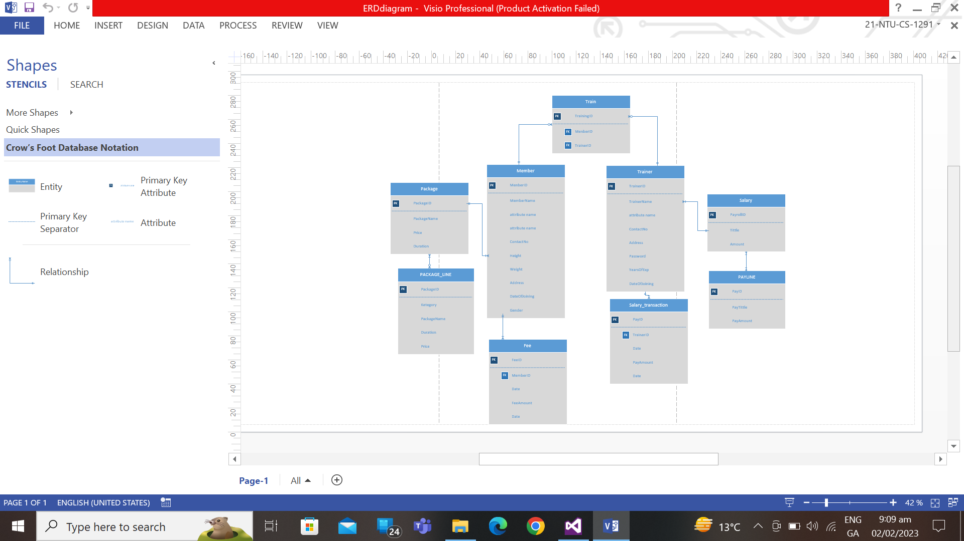

Use Case Diagram

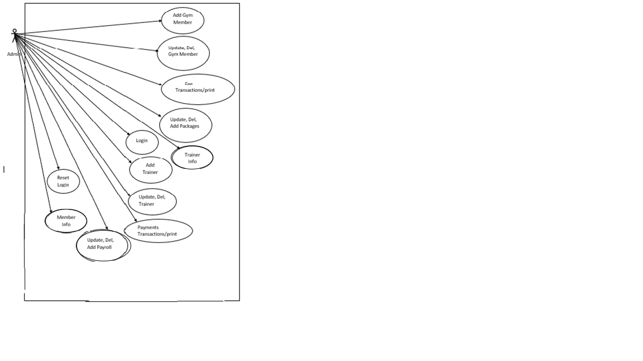

Activity Diagram
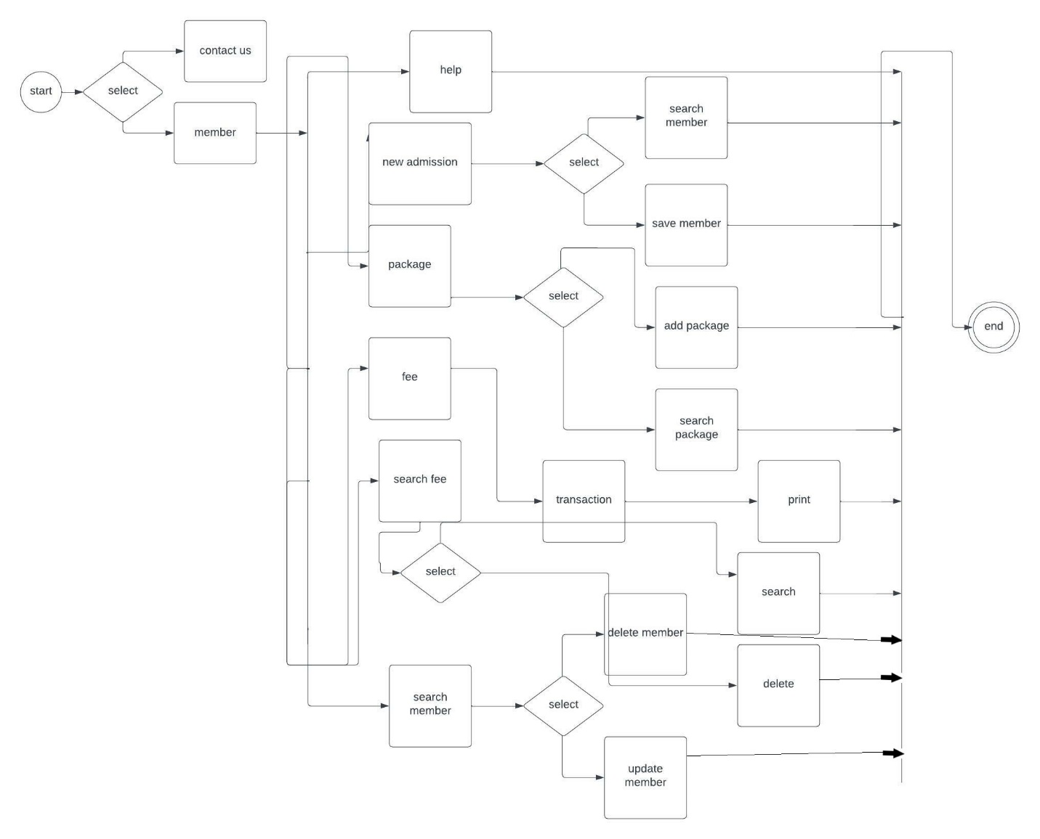

Class diagram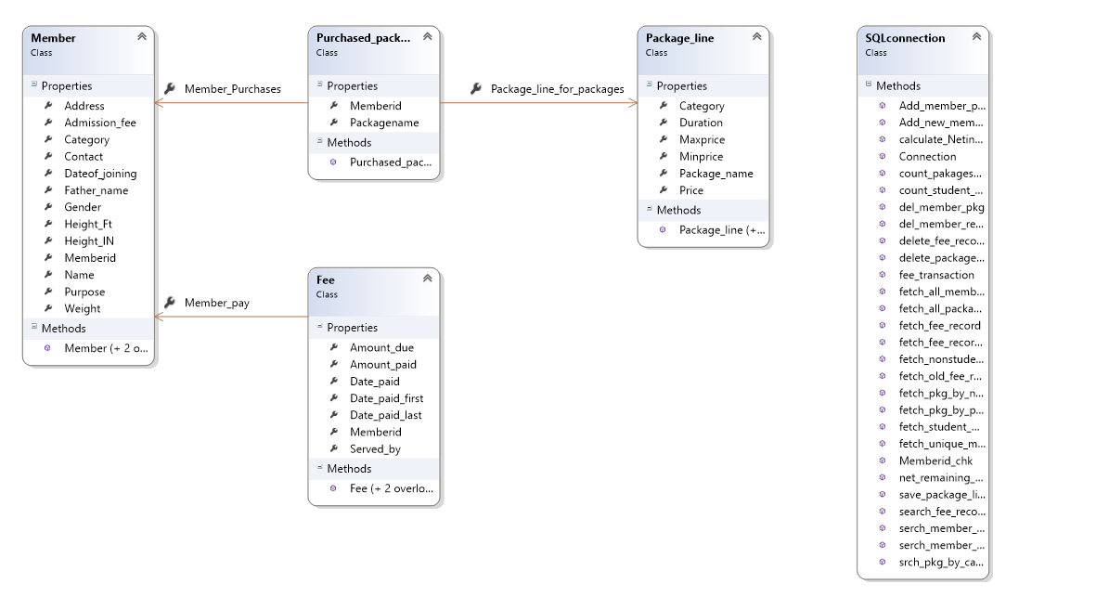

Data tables
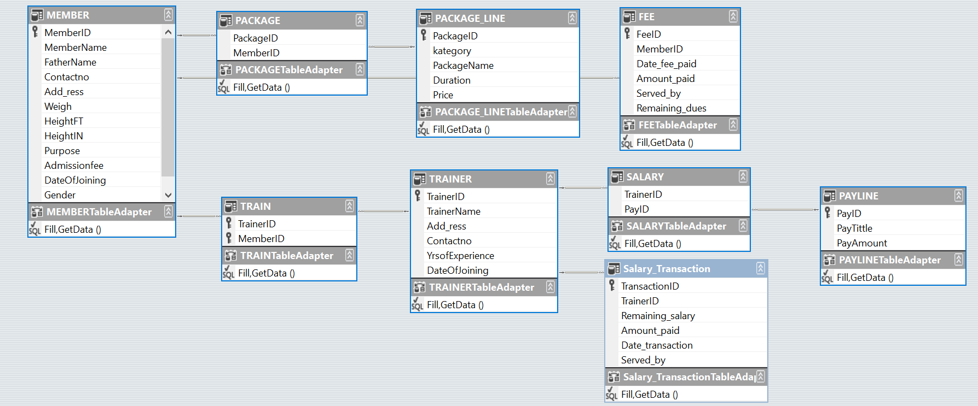

Data Flow Diagram
